 | Size age 2 | Size age 3-4 | Size age 5-6 | Cost each | Total Cost
Red polo shirt |  |  |  | £8.50
Blue polo shirt |  |  |  | £8.50
Yellow polo shirt |  |  |  | £8.50
Green polo shirt |  |  |  | £8.50
Red Sweatshirt |  |  |  | £9.00
Blue Sweatshirt |  |  |  | £9.00
Yellow Sweatshirt |  |  |  | £9.00
Green Sweatshirt |  |  |  | £9.00
Draw string bag | Red Blue Green Yellow |  |  | £4
Book bag |  |  |  | £4.50
Total cost

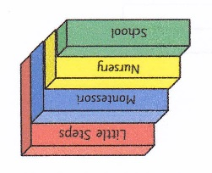
Little Steps Merchandise

We have red, blue, yellow or green sweatshirts and polo shirts available to buy as well as book bags and draw string bags all with the Little Steps logo on them.

These are not compulsory but can help protect your child’s own clothing. It is recommended that each child does have a book bag to transport library books and artwork.

Please fill in the form below and return it to Brenda, payment can be made
directly to Santander: sort code 09-01-29 account number 25094710, please use child’s name followed by ‘C’ as a reference.

Name of child __________________________________________

